
Year 7 Mathematics
Mini Test

Angles and Triangles

Resource Section: one A4 page of notes and calculator allowed

Time: 45 mins Name: _______________________________ / 40 marks

Full working out must be shown to get full marks. Attempt all the questions.

Part A 14 marks

Question 1: Correctly label the type of angles, angle relationships, triangles and shapes. 6 marks

Equilateral Triangle, Angles at a Point, Obtuse Angle, Complementary Angles, Alternate Angles, Reflex Angle.

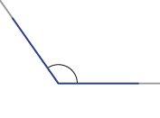  Answer: | 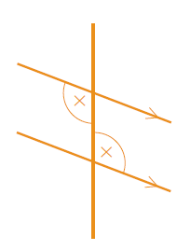  Answer: | 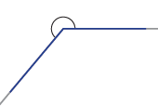  Answer:
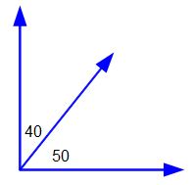  Answer: | 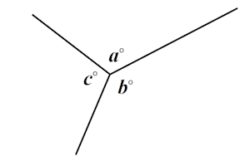  Answer: | 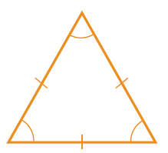  Answer:

Question 2: Measure the following angles and give the answer in degrees °. 2 marks

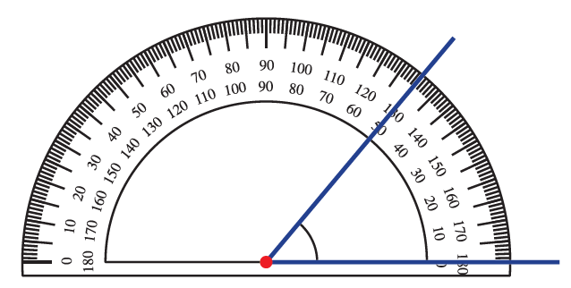  Answer: | 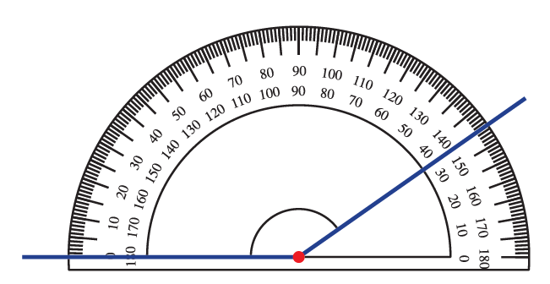  Answer:

Question 3: Using your protractor, measure the following angles and give the answer in degrees °.
3 marks
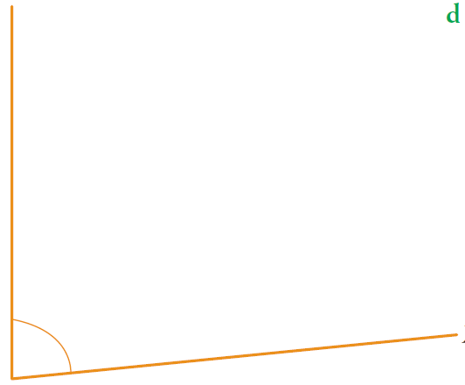  Answer: | 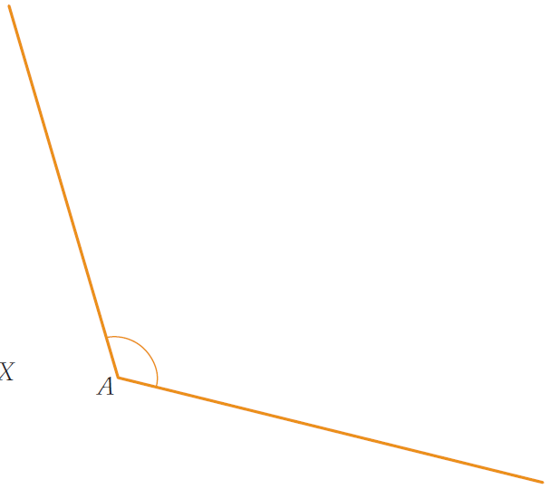  Answer:
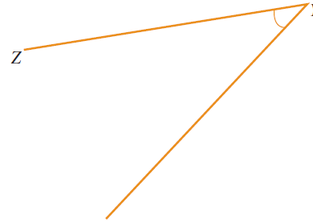

Answer:

Question 4: List all three possible names for the following angle. 3 marks

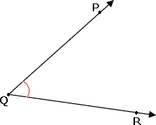

Part B 12 marks

Question 5: Without using a protractor, find the size of each angle marked with the letter a°. (The diagrams shown may not be drawn to scale) 4 marks

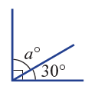  - Answer: | 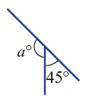  - Answer:
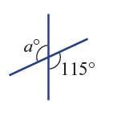  - Answer: | 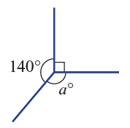  - Answer:

Question 6: 6 marks
- Find the value of a° in these diagrams. Don’t forget to include the degrees ( ° ).
- Name the angle relationship.

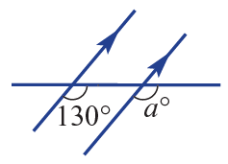 | 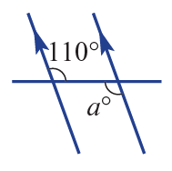 | 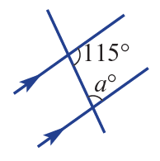

Question 7: Find the unknown angle a° in each of the following triangles. 2 marks

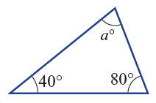  Answer: | 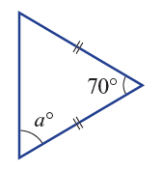  Answer:

Part C 10 marks

Question 8: Use a protractor and draw the following angles. 2 marks

- 135° |  | - 210°

Question 9: Find the values of a° and $x°$ in the diagrams. Give a mathematical reason for your answer. 8 marks
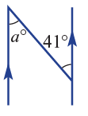  Answer: | 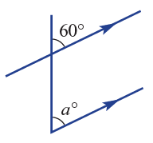  Answer:
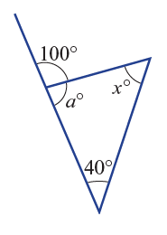

Answer:

Part D 4 marks

Question 10: Find a° in the following diagrams. Give a mathematical reason as to how you got your answer. 4 marks

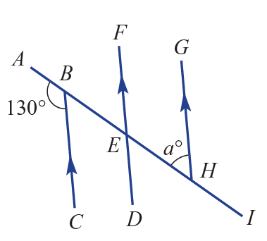  Answer: | 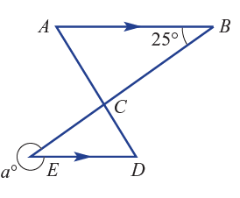  Answer:

End of Test

